NM PED Map 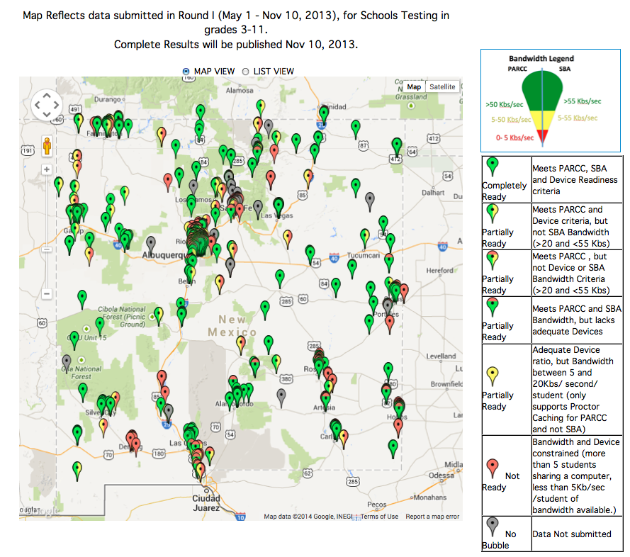
http://webapp2.ped.state.nm.us/SchoolData/TechFootPrint.aspx

