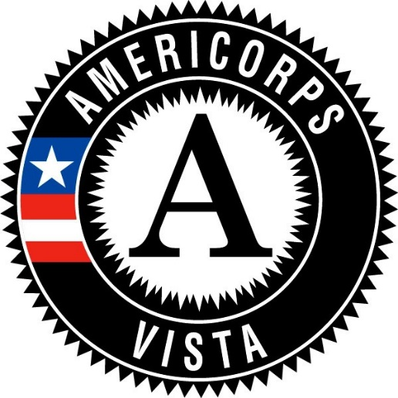

Apply Now!

Working with a terrific career development mentor, you’ll get to interact with leading technologists in government, federal laboratories, and private firms solving up-to-the-minute cyber security business development challenges.  • Conduct a state-by-state policy and strategy survey • Inventory cyber security tech transfer opportunities • Conduct business best practices and plan research • Develop a cyber security federal funding pipeline calendar • Conduct a business retention and expansion engagement with 30-50 firms • Develop a cyber security business development action plan for the State of New Mexico• Develop a New Mexico Cyber Security Cluster Guidebook. Your specialized skills will be highly appreciated and valued here. Applications will be evaluated on a rolling basis. Please feel free to reach out directly to the program contact listed.

**VISTA**

Become an AmeriCorps VISTA for Community & Economic Development

Take advantage of an opportunity to serve your community and country while gaining valuable skills and connections. The U.S. Department of Commerce’s Economic Development Administration (EDA) currently has a pilot program with the Corporation for National Community Service (CNCS) and the North Central NM Economic Development District to provide economic development capacity building services to economically distressed, rural communities in New Mexico. The position will provide an opportunity to work closely with local communities, regional organizations and Federal agencies while receiving hands-on training in economic development.

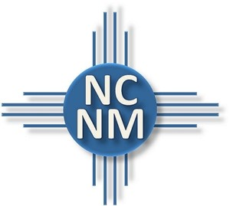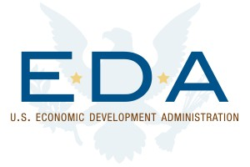`

**Start Date:** November 6, 2017

**Term:** 1 Year

**Apply at:** [Opportunity Link](https://my.americorps.gov/mp/listing/viewListing.do?id=76132&fromSearch=true)

**Contact:**

Scott Beckman

505-395-2676

scottb@ncnmedd.com

**Serve your country and improve the quality of life for economically distressed communities.**

**Invaluable hands-on economic development experience.**

**During Service**

* The position provides a $945/month living stipend.
* The volunteer position includes health care, child care, training, relocation expenses, and liability insurance.

**After Service**

* **Education Stipend** - After a successful year of service, VISTAs can choose to receive either a $1,800 stipend or a $5,920 Segal AmeriCorps Education Award.
* **Non-Competitive Eligibility (NCE) Status** - Once a VISTA successfully completes service that VISTA will receive one year of non-competitive eligibility for employment in the federal government. This special hiring status enables the former VISTA to apply for federal jobs with the advantage of not having to go through the standard public competitive selection process. That means that you can be appointed to federal positions that may or may not be available to the general public. NCE does not guarantee a federal job, but it does provide a valuable opportunity!

**For a full listing of benefits visit:** [**www.vistacampus.gov/in-service/benefits-service**](https://www.vistacampus.gov/in-service/benefits-service)

Benefits

The Corporation for National and Community Service (CNCS), a federal agency helps more than 5 million Americans improve the lives of their fellow citizens through service. Working hand in hand with local partners, CNCS tap the ingenuity and can-do spirit of the American people to tackle some of the most pressing challenges facing our nation. CNCS invests in thousands of nonprofit and faith-based groups that are making a difference across the country. CNCS includes AmeriCorps, Senior Corps, the Social Innovation Fund, the Volunteer Generation Fund, and more. They serve, we build, and we make an impact that changes lives and communities.

AmeriCorps VISTA members are passionate and committed to their mission to bring individuals and communities out of poverty. Members make a year-long, full-time commitment to serve on a specific project at a nonprofit organization or public agency. They focus their efforts to build the organizational, administrative, and financial capacity of organizations that fight illiteracy, improve health services, foster economic development, and otherwise assist low-income communities.

VISTA & CNCS