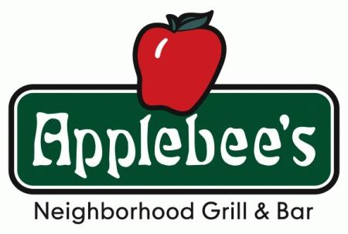
$15

Davis Band Boosters
Flapjack Breakfast Fundraiser
Sunday, January 14, 2018
8 – 10 am
Applebee’s, 1753 Research Park Dr, Davis
Come enjoy pancakes, sausage, scrambled eggs, and all the beverages that make breakfast great!
RAFFLE entry included with each ticket. Live music, too!
TICKET ORDER FORM
Student name: _______________________________________________________
Parent phone number or email: ______________________________________________
Band (circle): Concert / Symphonic / Jazz
***Each band student is requested to sell at least 3 tickets so we can fill up this event***
ORDER FORM DUE Friday, December 15th!!
Tickets will be available at will call on the day of the event.
Students MUST collect money and submit with this form.
Checks made out to: DHS Band Boosters
1. Name of Guest:
# of Tickets Ordered: __________ @ $15 = __________
Payment method (circle): Cash / Check / Credit Card
Name on Credit Card:________________________________________
Address for Credit Card:____________________________________________________________
Type of Credit Card: Visa, Master Card, Discover, American Express (please circle one)
Credit Card No.:
Expiration Date: Month_____ Year_______
Security Code: ______________ Zip code:_______________

2. Name of Guest:
# of Tickets Ordered: __________ @ $15 = __________
Payment method (circle): Cash / Check / Credit Card
Name on Credit Card:________________________________________
Address for Credit Card:____________________________________________________________
Type of Credit Card: Visa, Master Card, Discover, American Express (please circle one)
Credit Card No.:
Expiration Date: Month_____ Year_______
Security Code: ______________ Zip code:_______________

3. Name of Guest:
# of Tickets Ordered: __________ @ $15 = __________
Payment method (circle): Cash / Check / Credit Card
Name on Credit Card:________________________________________
Address for Credit Card:____________________________________________________________
Type of Credit Card: Visa, Master Card, Discover, American Express (please circle one)
Credit Card No.:
Expiration Date: Month_____ Year_______
Security Code: ______________ Zip code:_______________

4. Name of Guest:
# of Tickets Ordered: __________ @ $15 = __________
Payment method (circle): Cash / Check / Credit Card
Name on Credit Card:________________________________________
Address for Credit Card:____________________________________________________________
Type of Credit Card: Visa, Master Card, Discover, American Express (please circle one)
Credit Card No.:
Expiration Date: Month_____ Year_______
Security Code: ______________ Zip code:_______________

