Davis High School Band Boosters
P.O. Box 73522
Davis, CA 95617

Dear Patron and Supporter of the Arts,

In June 2018 two of Davis High School most acclaimed music ensembles, the Symphonic Band and Symphony Orchestra, have the exciting opportunity of a lifetime: to perform at Carnegie Hall in New York City! At the New York “Sounds of Summer” International Music Festival, the students will participate in workshops with Festival clinicians, as well as perform at Central Park and of course Carnegie Hall. This trip will inspire and educate them as young musicians and give them an opportunity like no other.

However, getting over 100 California students to this New York festival will cost well over $230,000. To help fund the trip, we are reaching out to businesses and professionals, supporters of the arts far and wide, with the hope that you can help our group by becoming a trip sponsor. As a sponsor we will place your logo on the back of our trip T-shirt, and will also provide you with advertising space in the programs of our 5 upcoming spring concerts. DHS Band Boosters is a 501c (3) nonprofit organization, thus all contributions are tax deductible to the extent allowed by IRS regulations.

Please see the accompanying forms with details on our different levels of sponsorships, and instructions on how to become a sponsor. Checks can be made payable to DHS Band Boosters. Please be sure to designate on your check that your donation is provided as a sponsor for the NY trip. You can participate by either printing and mailing the attached form, or emailing the form back to us. Please feel free to contact Cynthia Kerner if you have any questions at cjkerner@sbcglobal.net

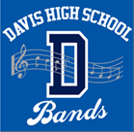
The Davis High School bands have earned multiple honors and awards over the years while providing valuable enrichment to each student’s educational experience. Davis High Bands also contribute to the engaging atmosphere of Davis: annual parade performances at Homecoming, Picnic Day, and the 4th of July by our beloved “Pep Band”; a Pops Concert at the Davis Farmers’ Market in May by the combined members of the Concert and Symphonic Bands; and special performances at various venues by the Jazz Band. The Davis High School band program has become recognized as one of the finest and most respected in California.

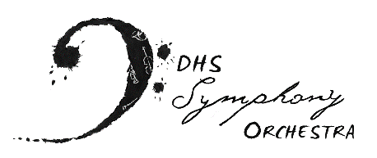
The DHS Symphony Orchestra provides a wide range of performance opportunities and orchestral literature for string, wind, brass and percussion student musicians. They perform annual outreach concerts for over 2,000 elementary aged students, accompany the Davis Madrigals, show case the winner of the annual DHS Concerto Competition, and recently were invited to perform with legendary Rock Violinist Mark Wood, a founding member of The Trans-Siberian Orchestra, at the Mondavi Center. The Symphony’s numerous honors and awards, both in state and nationally reflect the commitment of the dedicated student members and their Conductor Angelo Moreno, who provides a rich musical educational experience consistently each school year for his students.

Thank you so much for your generous support!

DHS Band Boosters
Federal Employee Identification #68-0240002
State Charity Registration #CT-121732

