Attention All Davis Residents!

March & Rally
for Public Education!
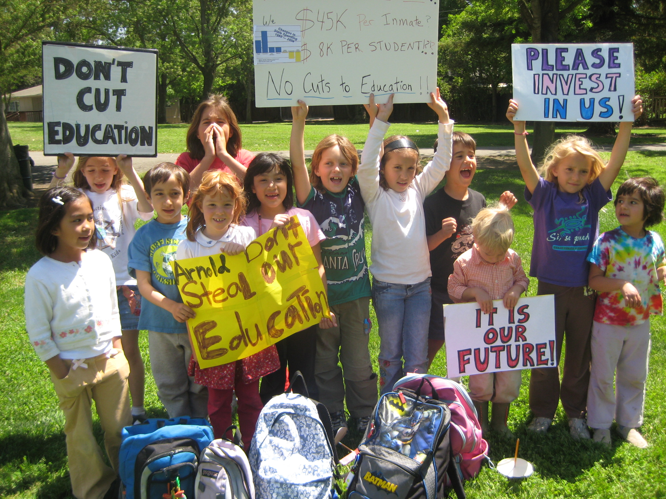

WEDNESDAY, MAY 14th Teacher’s Day

5:30 pm: Russell Blvd., at California Ave. (UC Davis) to Farmer’s Market.
6pm: Rally on north side (by oak tree platform) of Farmer’s Market.

California Teachers Association calling for a Statewide Day of Action!

STAND UP FOR CALIFORNIA’S FUTURE!
By joining “Davis Parents for California Schools” & the Davis Teachers Association in a MARCH TO PROTECT EDUCATION FUNDING IN THE STATE BUDGET!

California: 7th Largest World Economy but 46th in U.S. per pupil spending!!
For more information contact: Ines at (753-9656) or inesferreira@sbcglobal.net

According to The Education Coalition:

What does a $4.8 billion cut to
California public schools look like?

• Shutting down every school across the state for
nearly one month.

• Laying off more than 107,000 teachers.

• Increasing class sizes statewide by as much as
35%.

• Reducing per-student spending by more than
$800.

• Laying off over 137,000 bus drivers, janitors, food
service workers, maintenance workers, and other
education support professionals.

• Cutting more than $24,000 per classroom.

• Cutting $7.76 million per school district.

• Eliminating all music, art and career technical
education programs statewide with room to cut
even more.

$4.8 Billion = $4.4 billion cut from 2008-09 budget, and $400 million cut from 2007-

