Flute for Sale

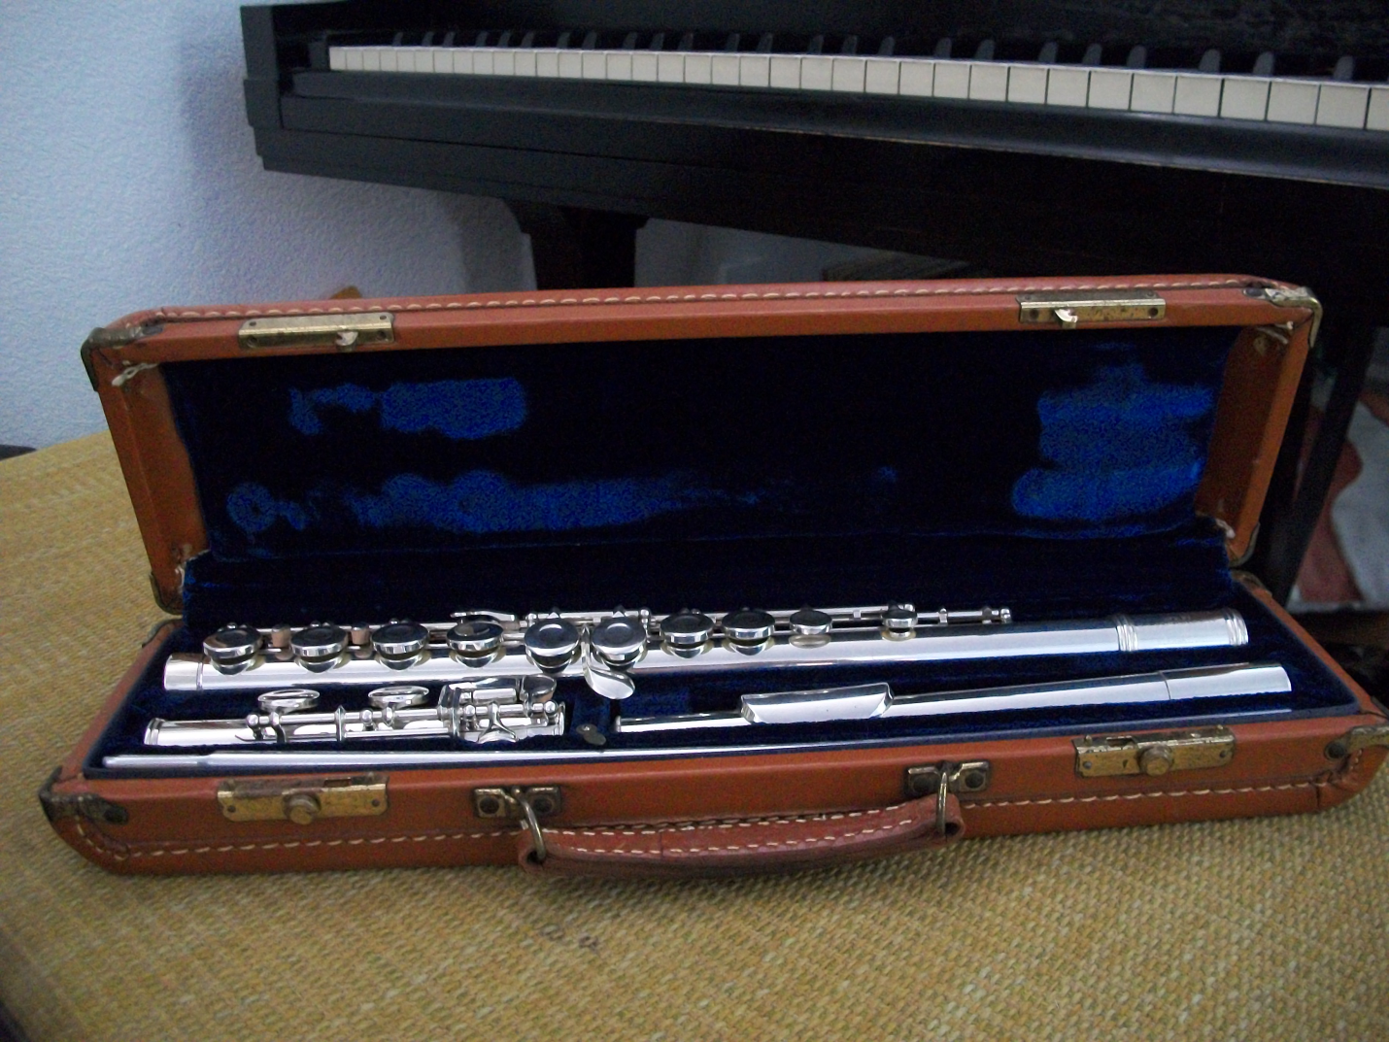

Gemeinhardt Flute
Equivalent of today’s 2sp model.
Just completely overhauled by John Gill at Got a Gig Music.
$450.00
Contact: Maki Kuper at maki.kuper@gmail.com or 756-7380
Piccolo for Sale

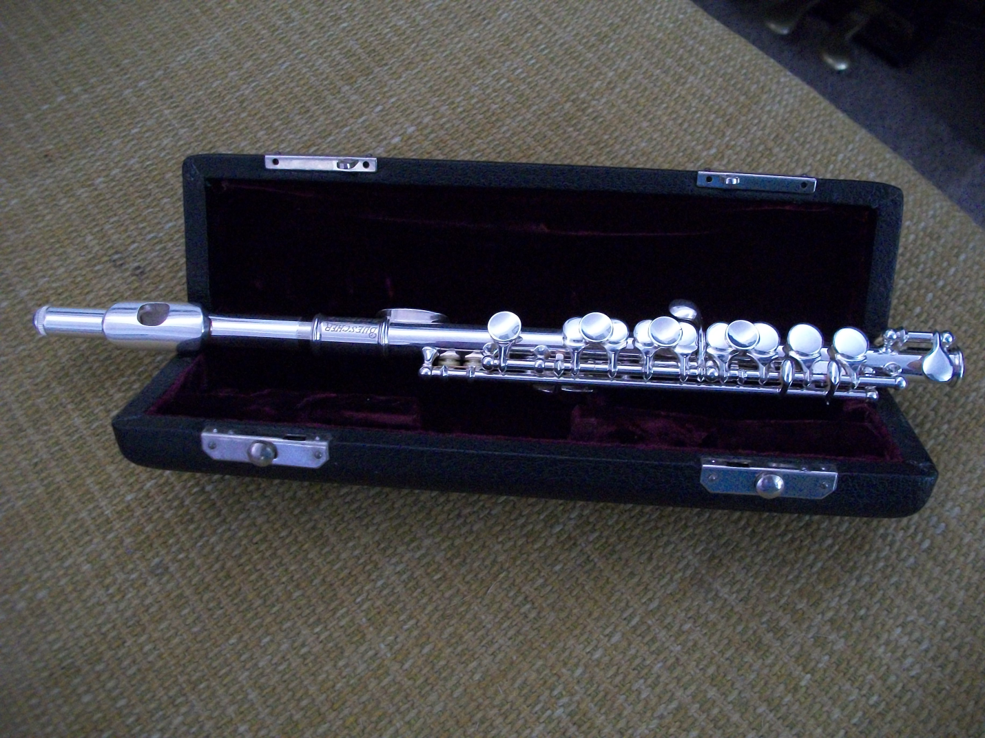

Buescher Piccolo made in Elkardt, Ind.
Just completely overhauled by John Gill at Got a Gig Music.
$400.00
Contact: Maki Kuper at maki.kuper@gmail.com or 756-7380

