The 2019 Davis High School Bands cordially invites you to a “No-Show Tea Party”
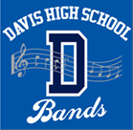
When: A day and time of your choosing
Where: Your favorite cozy chair
What: Enjoy a cup of tea, perhaps a book, and some Symphonic Band music:
https://www.youtube.com/channel/UCGqk-ZSxQBEnObsW8ovNwKQ

The three bands at Davis High School– Symphonic, Concert, and Jazz – have earned multiple honors and awards over the years while providing valuable enrichment to each student’s educational experience. Davis High Bands also contribute to the engaging atmosphere of Davis: annual parade performances at Homecoming, Picnic Day, and the 4th of July by our beloved “Pep Band”; a Pops Concert at the Davis Farmers’ Market in May by the combined members of the Concert and Symphonic Bands; and special performances at various venues by the Jazz Band.

DHS Band Boosters funds the bands’ yearly expenses including purchasing music, purchasing and repairing instruments, guest instructors, and performing in local musical festivals. In addition, every year the bands take a trip to experience other learning and performance opportunities. Recent trips have been performing at Carnegie Hall, and a unique recording session at Disneyland with Disney conductors and recording technicians, where they recorded scenes with the original scores to Disney’s classic animated movies. This next May 2020 we will be traveling to Seattle for music clinics at the University of Washington, then on to Victoria, B.C. to perform in the festivities of Canada’s Victoria Day.

To help fund many of the bands’ yearly expenses we are reaching out to family, friends, and supporters of the arts far and wide with the hope that you can help our group by sending a financial donation. Any amount is appreciated as every dollar will be used to offset the costs for these activities. DHS Band Boosters is a 501c (3) nonprofit organization, thus all contributions are tax deductible to the extent allowed by IRS regulations. Checks can be made payable to DHS Band Boosters. An envelope is enclosed for your convenience.

Please send your check to:
Davis High School Band Boosters
c/o Cynthia Kerner
2769 Concord Ave.
Davis, CA 95618

Or you can donate online through PayPal on the DHS Band Boosters Website:
http://groups.dcn.org/dhsbandboosters/paypal-page
With heartfelt gratitude for your support,

And the Davis Senior High School Bands Federal Employee Identification #68-0240002
DHS Band Boosters, P.O. Box 73522, Davis, CA 95617 State Charity Registration #CT-121732
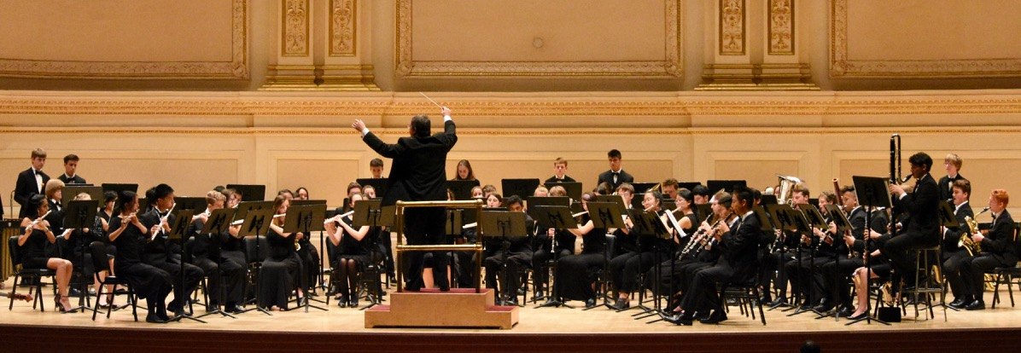
Carnegie Hall
New York City
June 2018

