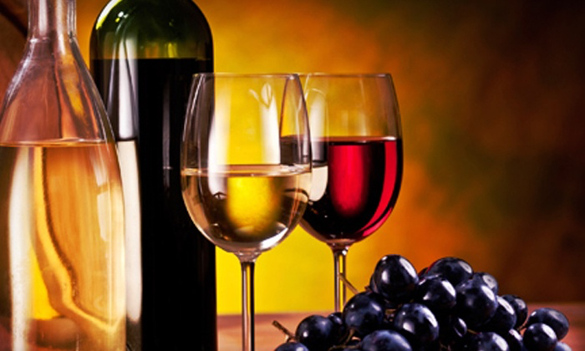
WINE TASTING & RAFFLE FUNDRAISER BERRYESSA GAP WINERY
____________________________________________________
SATURDAY APRIL 7, 2018
1:00 TO 3:00 PM
BERRYESSA GAP TASTING ROOM
27260 Hwy 128 WINTERS, CA 95694
____________________________________________________
-Come enjoy wine and snacks, while listening to music performed by members of the DHS Symphony Orchestra.
-Enter a raffle to win a wine tasting and tour for 8, generously donated by Berryessa Gap.
All proceeds to support the DHS Symphony Orchestra and DHS Band’s Carnegie Hall Tour 2018.
Tickets $30 http://groups.dcn.org/dhsbandboosters/paypal-page
For more information contact Jackie Lundy at mailto:jackielundy@earthlink.net

