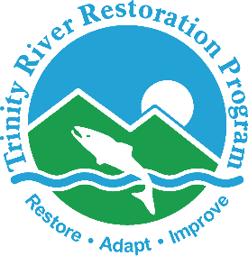

P.O. Box 1300, 1313 South Main Street, Weaverville, California 96093

Telephone: 530-623-1800, Fax: 530-623-5944

# Trinity River Restoration Program

Water Line - RGB

On Dec 6, the Trinity River Management Council will be considering a technical flow recommendation for variable flows between February and April of 2018. The draft flow recommendation includes three small pulse flow releases during the typical winter baseflow release period (Figure 1). Each flow pulse would start at the 300 cfs winter baseflow, include a 1 day ramp up to a maximum flow release of 1,800 cfs (held for 5 hours starting in the late afternoon), then gradually ramp down back down to 300 cfs over 5 days. Peak flows are scheduled on Tuesdays (February 6; March 13; and April 10). The recommended flows would require 20,000 acre-feet of water in addition to the water utilized for the 300 cfs winter baseflow releases during this time period. The releases would be within the Trinity Dam power plant capacity during its scheduled maintenance period this year. The effects of the recommended flow releases on drift forage concentration for juvenile Chinook salmonids would be monitored if the flow releases are approved.

**DRAFT - Subject to Change**



**Figure 1: Proposed Flow Releases from Lewiston Dam to the Trinity River for Febuary 1 to April 17, 2018**